PERTEMUAN 3 (28092102)

**MENU, POPUPMENU, LAYOUT**

**MENU**

Koding menubar → JMenuBar menubar = new JMenuBar();

Memasang menubar pada Frame → fr.setJMenuBar(menubar);

Membuat menu pada menubar → JMenu menuFile = new JMenu("File");

Submenu pada menu File → JMenuItem miFileNew = new JMenuItem("New");

JMenuItem miFileOpen = new JMenuItem("Open");

Memasang submenu → menuFile.add(miFileNew);

Menambahkan separator → menuFile.addSeparator();

Submenu pada submenu → JMenu miFileRecent = new JMenu("Recent");

int jumlahSubmenu = 3;

for (int i=0; i<jumlahSubmenu; i++){

miFileRecent.add(new JMenuItem(“File”;(i++()));

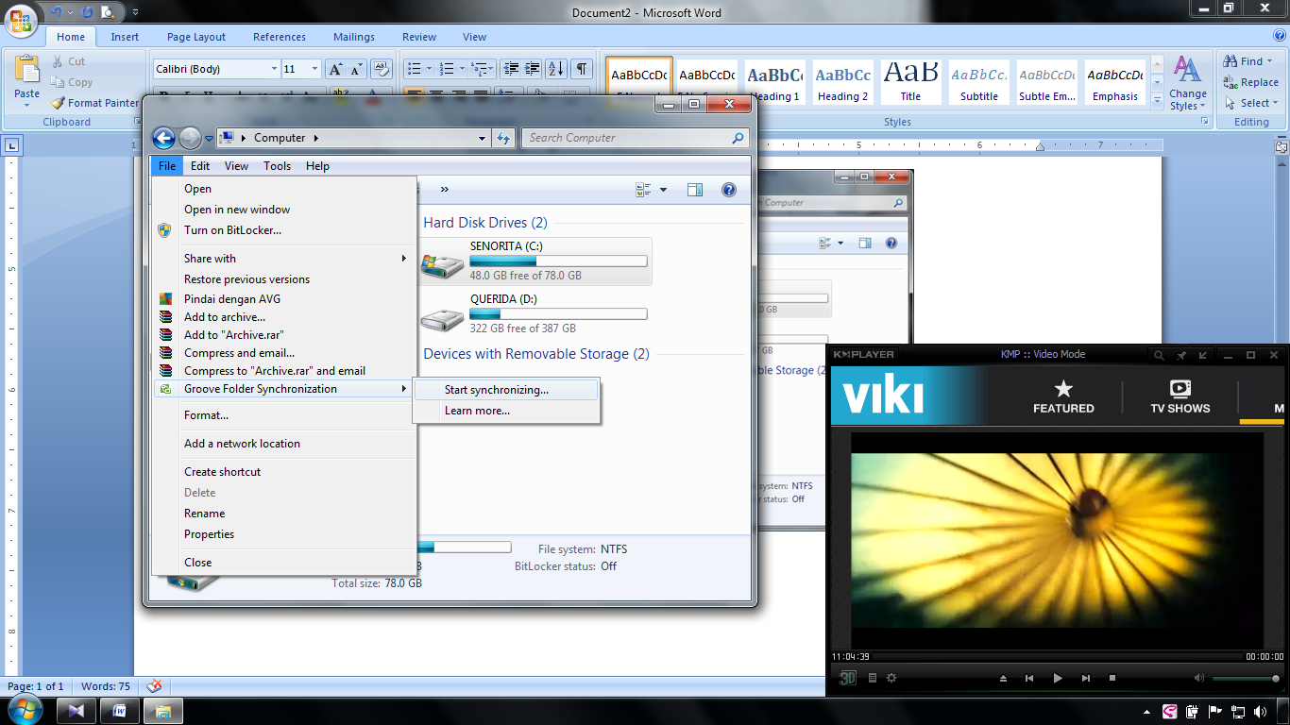

JMenu

frame

menubarbar

JMenuItem

JMenu

**POPUPMENU**

Sama seperti memasang koding menu, tetapi ditempel lagi di frame

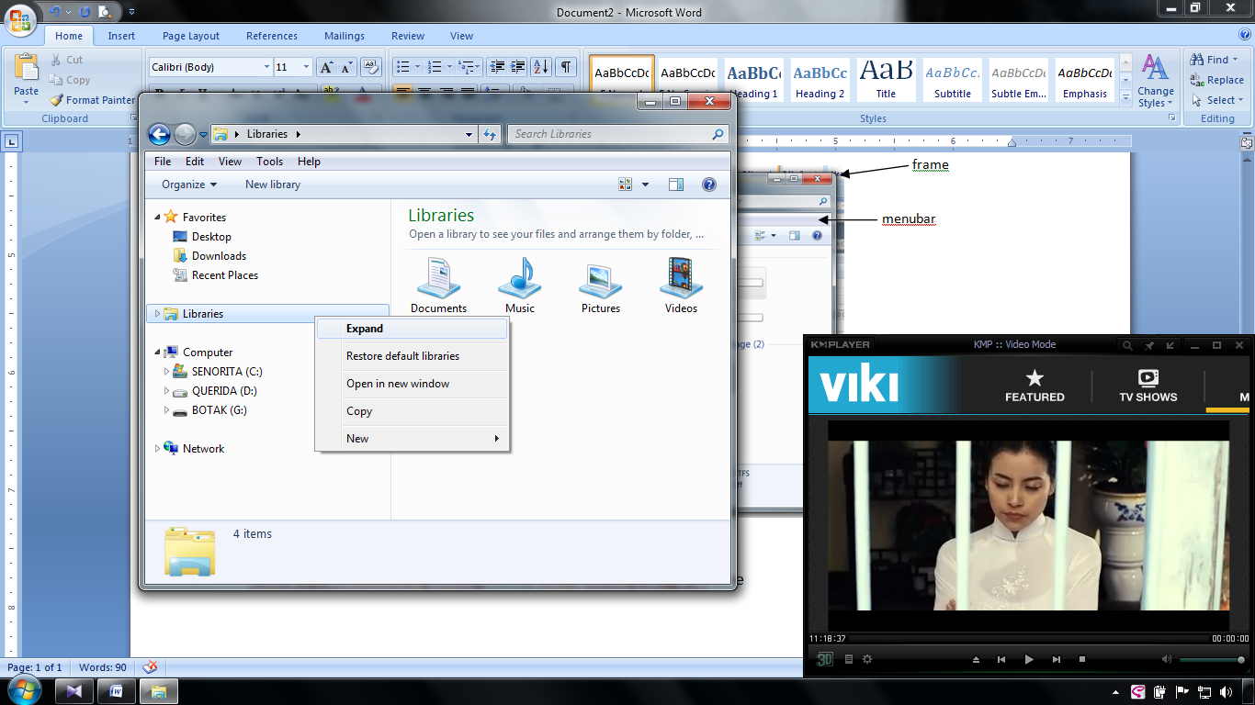

popup menu

**LAYOUT**

Terdapat 3 layout :

* Flow Layout → ukuran masing-masing dipertahankan
* Grid Layout → mengikuti barisnya (setting baris :: panel.setLayout = new GridLayout(3,2); )
* Border Layout → NORTH, SOUTH, WEST, EAST, CENTER layout

|  |  |  |  |  |  |
| --- | --- | --- | --- | --- | --- |
|  |  |  |  |  |  |
|  |  |  |  |  |  |
|  |  |  |  |  |  |
|  |  |  |  |  |  |
|  |  |  |  |  |  |
|  |  |  |  |  |  |

GRID LAYOUT



FLOW LAYOUT

NORTH

CENTER

SOUTH

BORDER LAYOUT